**MSEG 302 – Final Exam, 18 May 2017**

Student Name ____________________________________ Seat Number:____________

Student Number __________________________________

Mark your answer on the Scantron page AND on the test. Do not write your answer in the margin. If you do not write an answer on the Scantron page then you will NOT get credit. Each question is worth 3 points, the last question is worth 1 point.

**1.** The X-ray radiation Cu Kα is produced by:

a. an electron falling to a lower energy level and giving off energy

b. the nucleus releasing a proton

c. light striking the surface of Copper metal

d. gaining an electron to make a new isotope

e. none of the above

**2.** Determine the diffraction angle an experimenter would plot on a graph, using CuKα radiation, for the (110) set of planes if the unit cell has a lattice parameter of   
0.291 nm.

a. 22.0° b. 44.0° c. 11.0° d. 33.0°

**3.** What type of interference is necessary to characterize a material with x-ray scattering?

a. constructive b. destructive

c. no interference d. both a. and b.

**4.** It is possible to determine the number of vacancies in a material by:

a. using x-ray scattering

b. measuring the length of a bar as it is heated

c. measuring its mass as a function of temperature

d. both a. and b. e. using a., b. and c.

**5.** Grain boundaries are:

a. point defects b. line defects

c. area defects d. all the above

e. none of the above

**6.** The equilibrium fraction of vacant lattice sites in Silver is 10-6 at 600°C, calculate the number of vacancies at this temperature. The density of Silver is 10.35 g/cc.

a. 5.78×1022 #/m3 b. 5.78×1016 #/m3

c. 5.58×1021 #/m3 d. 6.23×1024 #/m3

**7.** Calculate the number of vacancies per cubic meter at 900°C for a metal that has an energy for vacancy formation of 1.22 eV/atom, a density of 6.25 g/cc, and an atomic weight of 37.4 g/mol.

a. 5.79×1023 #/m3 b. 5.79×1017 #/m3

c. 1.49×1022 #/m3 d. 2.57×1024 #/m3

**8.** How many scattering peaks do you need to know to determine if a material has a simple cubic versus a body centered cubic crystal structure?

a. 1 b. 3 c. 5 d. 6 e. 7

**9.** Determine the crystal structure of this material.

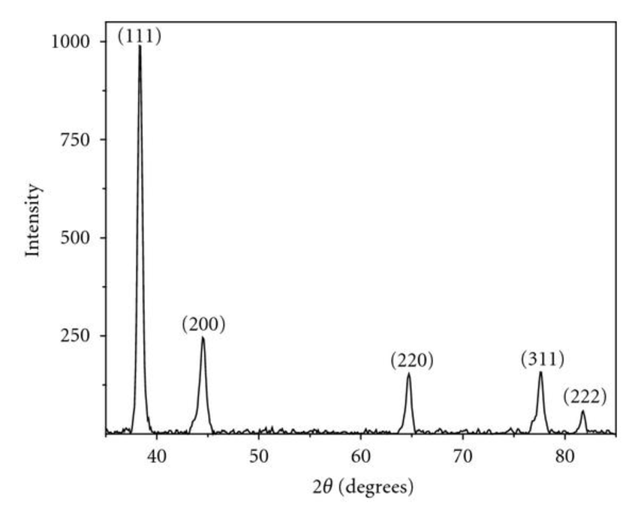

a. Simple cubic b. FCC

c. BCC d. none of these

**10.** Determine the lattice constant for the material in Problem 9 assuming CuKα radiation is used.

a. 0.154 nm b. 0.330 nm

c. 0.564 nm d. 0.407 nm

**11.** A cylindrical nickel wire 2.0 mm in diameter and 3×104 mm long has a 300 N load put on it. Determine its length change assuming the deformation is totally elastic.

a. 1.38×10-5 mm b. 13.8mm

c. 1.38×104 mm d. 1.38×1010 mm

**12.** A steel alloy must have a modulus of resilience of at least 2.07 MPa. What must be its minimum yield strength?

a.8.57 MPa b. 2.93 MPa

c. 29.3 MPa d. 926 MPa

**13.** A metal has a dislocation density of   
108 mm-2. Assume the dislocations in a 1 cm3 cube can be laid end-to-end and determine their length.

a. 105 m b. 106 m

c. 107 m d. 108 m

**14.** A glass plate is subjected to a tensile stress of 40 MPa. If the specific surface energy and elastic modulus are 0.3 J/m2 and 69 GPa, respectively, determine the critical crack length for a surface crack.

a. 4.1 µm b. 8.2 µm

c. 16.4 µm d. 24.6 µm

**15.** An S-590 iron component must have a creep rupture lifetime of at least 30 days at 600°C. Compute the maximum allowable stress level.

a. 800 MPa b. 700 MPa

c. 350 MPa d. 250 MPa

**16.** Salt is used to “melt” water with its phase diagram given at the end of the exam. If you have a 10 wt% salt solution that you cool to -10°C what is the salt concentration in the liquid phase?

a. 0.0 wt% b. 13.5 wt%

c. 24.0 wt% d. 76.0 wt%

**17.** Determine the percentage change in the tensile strength of a brass rod if its diameter is reduced by 25% by cold work.

a. 10% b. 50%

c. 75% d. 100%

**18.** Which of the following are the most common coordination numbers for ceramic materials?

a. 6, 8, and 12 b. 4, 6, and 8

c. 2 and 3 d. 6 and 12

**19.** Calculate the fraction of lattice sites that are Schottky defects for cesium chloride at 532°C (this temperature is below the melting temperature (645°C)). Assume an energy for defect formation of 1.86 eV.

a. 1.5×10-6 b. 2.3×10-12

c. 2.4×10-18 d. 1.6×10-9

**20**. Calculate the theoretical density of FeO given that it has the rock salt structure. The ionic radius of Fe2+ and O2- are 0.077 nm and 0.140 nm, respectively.

a. 1.46 g/cm3 b. 5.84 g/cm3

c. 7.68 g/cm3 d. 10.4 g/cm3

**21.** How does the electron structure of a solid material differ from that of isolated atoms?

a. there is no difference

b. an isolated atom has a band structure while solid materials have discrete electron energy states

c. the solid material has a band structure while isolated atoms have discrete electron energy states

d. the electrons in solid materials affect the nucleus more

**22.** Which of the following has a significant effect on a material’s electrical resistance?

a. vacancy concentration b. temperature

c. percent cold work d. all the above

**23.** The room temperature electrical conductivity of a semiconductor specimen is 2.8 x 104 (Ω-m)-1. The electron concentration is known to be 2.9 x 1022 #/m3. Given that the electron and hole mobilities are 0.14 and 0.023 m2/V-s, respectively, calculate the hole concentration (in m-3).

a. 7.4×1024 #/m3 b. 2.1×1024 #/m3

c. 6.0×1023 #/m3 d. 5.7×1021 #/m3

**24.** Most ionic ceramics have band gap structures that are most similar to those of:

a. semiconductors b. insulators

c. metals d. all of the above

**25.** A 30 wt% Tin concentration in a Lead-Tin solder is cooled from 350°C, what is the temperature where the first solid is formed?

a. 327°C b. 183°C

c. 255°C d. 232°C

**26.** The same material as in Question 25 is cooled to 200°C. What is the concentration of Tin in the solid phase?

a. 17.5 wt% b. 56.0 wt%

c. 18.3 wt% d. 61.9 wt%

**27.** What is the weight percent of the solid phase in Question 26?

a. 18.5 wt% b. 32.5 wt%

c. 67.5 wt% d. 100 wt%

**28.** If its temperature is increased, what will happen to the resistance of a metal?

a. it will increase b. it will decrease

c. it will stay the same

**29.** Nitrogen, from a gaseous phase, is to be diffused into pure iron at 700°C. If the surface concentration is maintained at 0.1 wt% Nitrogen, what will be the concentration 1 mm from the surface after 24 h in wt%? The diffusion coefficient for nitrogen in iron at 700°C is 2.5 × 10-11 m2/s.

a. 0.1 wt% b. 0.046 wt%

c. 0.054 wt% d. 0.063 wt%

**30.** The percent ionic character of Lithium Flouride is?

a. 9% b. 91%

c. 100% d. 54%

**31.** It is possible to have a bond that is 100% covalent.

a. true b. false



The following two questions refer to the above figure.

**32.** What are the índices of the vector (a negative value is indicated by a negative sign rather than an overbar)?

a. [-101] b. (-101) c. [-1-43] d. (-1-43)

**33.** What is the y coordinate for the end (where the arrow head is) of the vector?

a. 0 b. ½ c. 1 d. - ½

**34.** I will have a great summer because:

a. I am awesome

b. I have finished MSEG 302

c. I can sleep a lot

d. I get to spend more time with my friends

|  |
| --- |
| **_____________________________________________________________________________________**  **Values of Selected Physical Constants** |
| | **Quantity** | **Symbol** | **SI Units** | **cgs Units** | | --- | --- | --- | --- | | Avogadro's number | *N*A | 6.022 × 1023 molecules/mol | 6.022 × 1023 molecules/mol | | Boltzmann's constant | *k* | 1.38 × 10−23 J/atom · K | 1.38 × 10−16 erg/atom · K  8.62 × 10−5 eV/atom · K | | Bohr magneton | *μ*B | 9.27 × 10−24 A · m2 | 9.27 × 10−21 erg/gaussa | | Electron charge | *e* | 1.602 × 10−19 C | 4.8 × 10−10 statcoulb | | Electron mass | — | 9.11 × 10−31 kg | 9.11 × 10−28 g | | Gas constant | *R* | 8.31 J/mol · K | 1.987 cal/mol · K | | Permeability of a vacuum | *μ*0 | 1.257 × 10−6 henry/m | unitya | | Permittivity of a vacuum | ϵ0 | 8.85 × 10−12 farad/m | unityb | | Planck's constant | *h* | 6.63 × 10−34 J · s | 6.63 × 10−27 erg · s  4.13 × 10−15 eV · s | | Velocity of light in a vacuum | *c* | 3 × 108 m/s | 3 × 1010 cm/s | |

CuK radiation wavelength is 0.154 nm.

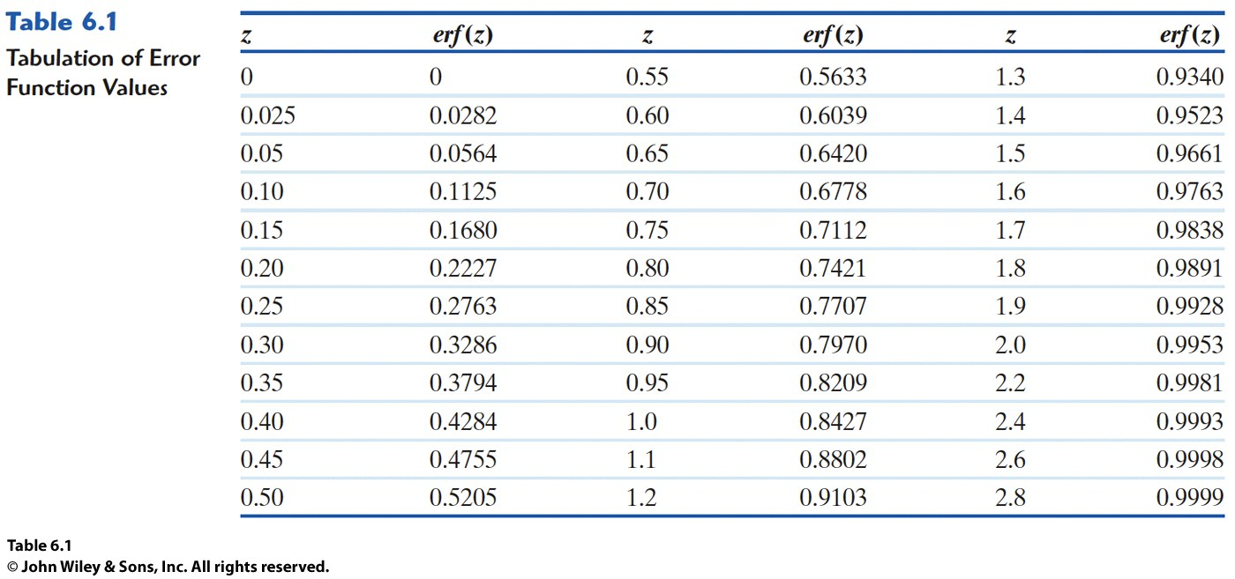

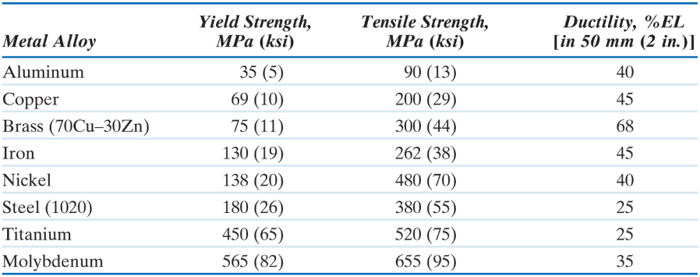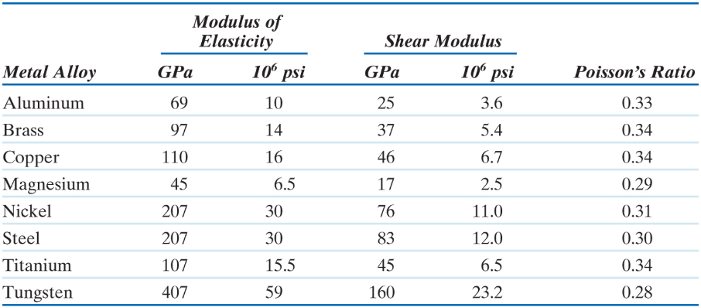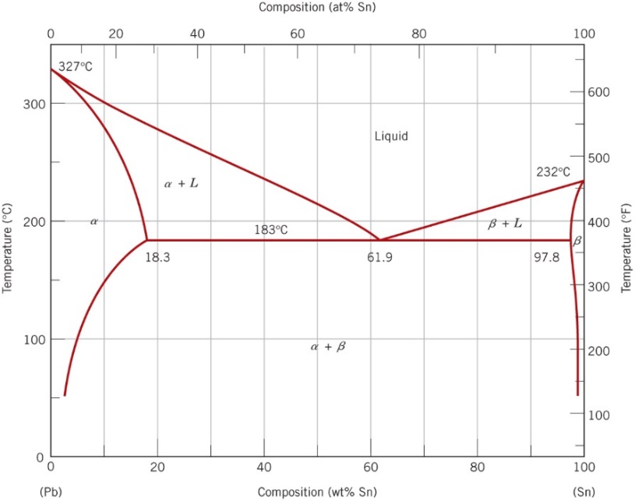

Lead – Tin phase diagram

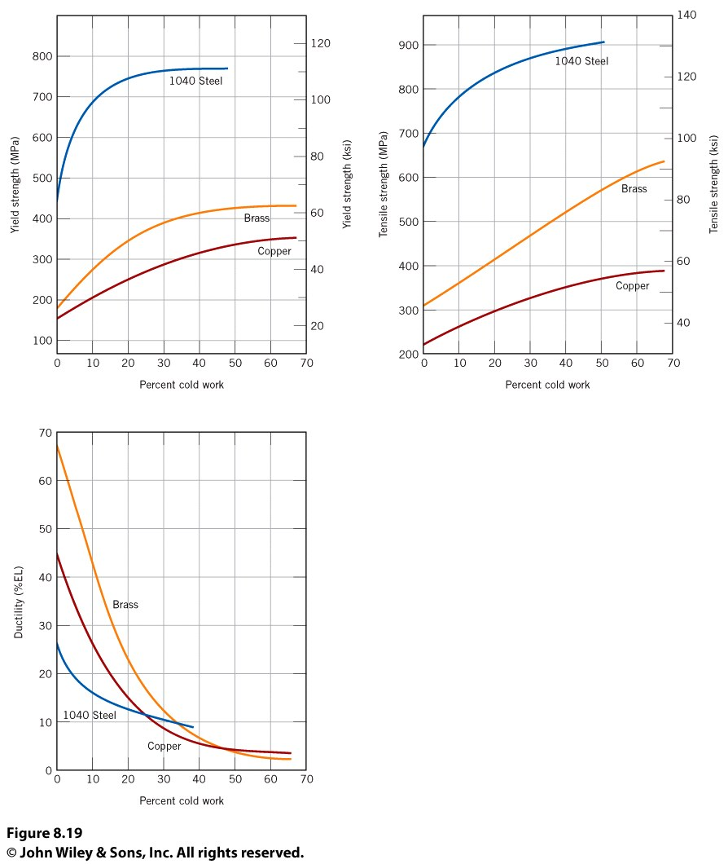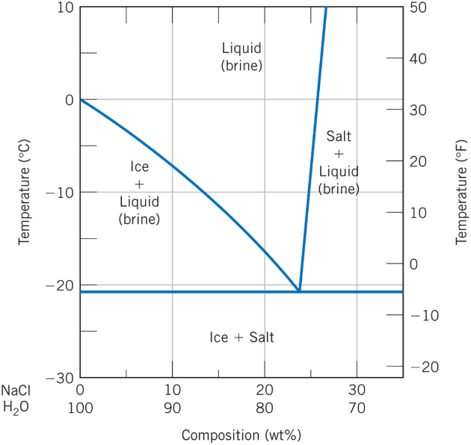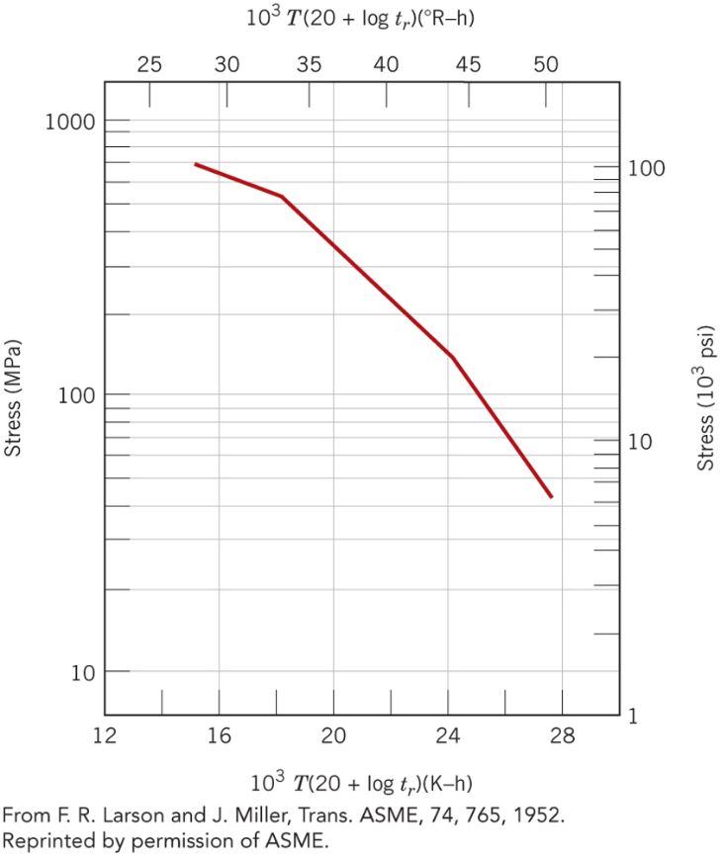

S590 Iron